ST. LAWRENCE COUNTY

WORKFORCE DEVELOPMENT BOARD



Financial, Administrative, Program Review Guide

Approved by the St. Lawrence County Workforce Development Board: 06/12/2024

ST. LAWRENCE COUNTY
Financial, Administrative, Program
Review Guide
Workforce Innovation and Opportunity Act

Subrecipient/Contractor Fiscal Oversight:

Identification of Subrecipients and Contractor:
Subrecipient: A non-federal organization that receives funds indirectly (via a pass-through entity) to carry out part of a federal program (not including an individual that is a beneficiary of such program.)

Contractor: An entity that utilizes a legal agreement for the purchase of goods or services. This may include a dealer, distributor, merchant or other seller of routine goods or services that are required to carry out a federal program. If services provided by the contractor are programmatic in nature, fiscal and program monitoring of such programmatic services is still required. This monitoring must be tailored to the programmatic service to ensure that the services are provided in compliance with all relevant federal fiscal, program and grant agreement requirements.

Exhibit E will be used to help determine the identification of subrecipients.

The Function of Monitoring Review:
The St. Lawrence County Assistant Accounting Supervisor and/or Senior Account Clerk will monitor with on site visits and desk reviews the following items if it is determined they pertain to the Fixed Fee Agreement payment. Technical Advisory #21-4 & Technical Advisory #21-5 and the NYSDOL monitoring guides will be utilized in conducting the monitoring review. The guides can be found at https://labor.ny.gov/workforcenypartners/wioa/wioa-monitoring-guides.shtm.

A. The focus of the monitoring visits will be to determine if the subrecipient financial system provides the following:
- Effective internal controls to safeguard funds and assure proper use
- A comparison of actual expenditures with the budgeted amounts in each contract
- Cash management controls that limit cash advances to actual immediate disbursements
- Determine that program costs have been correctly charged and documentation to support these costs have been retained.
- All costs have been charged to the appropriate cost categories and are within the cost limitations specified in the WIOA Act and the Federal Register.
- Require a copy of the Sub Recipient’s annual single audit if they expend over $750,000.00 in Federal Funding in one year per2 CFR 200.501(b). See Attachment A-1
- All services are in compliance with the WIOA Act and other regulations or laws that are applicable to the WIOA Program.
- The Assistant Accounting Supervisor will offer Technical Assistance when required by subrecipient or deemed necessary by St. Lawrence County and is appropriate. Technical Assistance will be offered by phone, in writing or on-site, if deemed necessary. The Assistant Accounting Supervisor or Senior Account Clerk will provide the Technical Assistance. Technical assistance could include but is not limited to:
- Conference calls/virtual meeting
- Sample of different forms used
- Sample of policies needed
- Describing what documentation is needed
- Answering questions about what is allowable under the scope of the contract
- Monitor Reviews will be conducted as follows: (agencies to be monitored – See Attachment A-3)
  - Financial Management review will be at least an annual visit or if required by either parties of the contract on a more frequent basis. The review will be conducted during the months of July through October.
  - Desk Reviews will occur each time a Request for Reimbursement and Monthly Expenditure Report is received. For Desk review see Attachment B
  - EEO Requirements will be monitored on a yearly basis. The review will be conducted during the months of July through October. See Attachment C
  - Procurement & Property Management Reviews will occur biennially. The review will be conducted during the months of July through October.

B. Summary Observations and Remediation:
- Subrecipients will be notified in writing of any findings resulting from the review, within 45 days of the review. A significant finding includes those that a) have a material impact on financial reports submitted to NYSDOL, b) have a material impact on the ability of the LWDB to meet established program performance measures and/or c) represent substantial violations of statutory and regulatory requirements. If required by either party, an on-site visit will be made to discuss the findings. St. Lawrence County may do another on-site monitoring visit to determine if corrective actions have taken place. If corrective actions have not taken place, funding to the Sub Recipient may be discontinued, until such time corrective actions have taken place.
- The St. Lawrence County Workforce Development Board Chair and its Executive Director will be notified in writing of the results of the review, within 45 days of the review.
- NYSDOL Financial Oversight and Technical Assistance and State Program representatives will be notified in writing of the results of the review, within 45 days of the review.
- The Chief Elected Official will also be notified in writing of the results of the review, within 45 days of the review.
- Resolution process of findings from the Monitoring Review. See Attachment D
- A Monitoring Review File will be maintained for each Sub Recipient, which will include a written report for every Fiscal on-site Visit and Fiscal Desk Review.
- The St. Lawrence County LWDA will retain the Monitoring Review File for a minimum of seven (7) years.
- Staff Personnel who will perform monitoring:
a. Assistant Acct Supervisor-Financial Management, Procurement & Property Reviews
b. Senior Account Clerk – Financial Management, Procurement & Property Reviews

Compliance with new Requirements set forth by NYS DOL:

The Subrecipient/Contractor Fiscal Oversight Review Policy will be adjusted accordingly, upon receipt of any new directives, Technical Advisories, OMB 2 CFR 200 Cost Principles or revision to the afore mentioned documents that, address changes to Subrecipient /Contractor Fiscal Oversight Review.

Fiscal and Administrative Compliance Requirements Review:

St. Lawrence County Fiscal agent will Monitor each Subrecipient and receive a copy of the entities single audit if it expends more than $750,000 in federal awards. Audit reports will be requested to be submitted within thirty (30) days after receipt of auditor’s report or not later than nine months after the end of the auditee’s fiscal year. See Attachment A-1. The audit will be reviewed using the Audit Review Checklist for Single Audits. See Attachment A-2. If there are audit findings then the Fiscal Agent will determine the need for and ensure the implementation of correction action for all findings that impact the program, allow or disallow all questioned costs and provide the basis for each such determination and establish a debt (where appropriate) and indicate the method of repayment planned or required.

Subrecipient Monitoring Activity

A subrecipient shall not contract with a subcontractor to perform any work, labor services, duties or functions without written approval from the St. Lawrence Workforce Development Board. The subrecipient shall be responsible for all WIOA funds received and shall be responsible for the actions of its subcontractor. All provider subcontracts entered into by the Subrecipient are subject to the WIOA Financial Management Review according to the Workforce Development System Technical Advisories #-21-4 & 21-5. The St. Lawrence County Fiscal agent will be responsible to perform the subrecipient monitoring of their review. The review will be conducted during the months of July through October.

Program Monitoring and Oversight:

Program Monitoring for Youth, Adult and Dislocated Worker Services as provided by WIOA Staff:

A non-counseling staff member annually will monitor files, documentation, and data entry in the One Stop Operating System for the purpose of oversight of local Youth, Adult and Dislocated worker activities as authorized under the Workforce Innovation and Opportunity Act. The monitor will complete and submit a written report to the Executive Director to present to the Workforce Development Board regarding the accurate documentation of eligibility, required data validation information and the provision of services to WIOA Youth, Adults, and Dislocated Workers.

The focus of the monitoring will be to determine if the participant case files (hardcopy and electronic) are accurate, reliable and up-to-date. For Youth, the participant data reported in the One Stop Operating System must accurately reflect the data in the participants file. For Adults and Dislocated Workers the participant data is found primarily in the One Stop Operating System with a participants file containing documentation required for data validation or in the case of the use of Trade Act funds will contain the required TAA documentation. The following procedures will be utilized:

- Annually a minimum of 5% of all participants served in the prior program year will be randomly selected by the WIOA Supervisor and assigned to a non-counseling staff member for program monitoring.
- The instruments that will be used for the monitoring will be file review checklists that allows the staff person to visually inspect customer files to verify that the proper source documentation used to validate data elements are recorded and included in the file. The staff will also verify that required WIOA enrollment forms, IEP’s, ITA’s and other necessary paperwork is present in the file.
- The staff person will review the OSOS record of the selected customer to monitor that DEV, activities, services, outcomes and counselor comments have been accurately recorded.
- Upon completion, a report will be submitted to the WIOA Supervisor and the Executive Director of the WDB stating his/her findings and these findings will be reviewed with all staff providing services so that corrective action, if needed, may be taken.
The WDB Executive Director will report these findings to the Workforce Development Board at its next scheduled meeting

Monitoring of Performance Measures
On a quarterly basis the WIOA program supervisor will review and monitor the Primary Indicators of Performance for Youth, Adult and Dislocated Worker. Any measures that the LWDA program is failing will be discussed with the Executive Director of the WDB and a discussion of what actions need to be taken will be conducted with the WDB.

Technical Assistance will be provided when required by subrecipient or deemed necessary by St. Lawrence County and is appropriate. Programmatic Desk Monitoring Reviews will occur on a quarterly basis for ongoing services

Technical Advisory #21-4 and 21-5 will be utilized in conducting the monitoring review.

Summary Observations and Remediation
- Subrecipients will be notified in writing of any findings resulting from the review, within 45 days of the review. If required by either party, an on-site visit will be made to discuss the findings. If the Subrecipient does not file a Complaint/Grievance within 30 days of notification, St. Lawrence County will do another on-site monitoring visit to determine if corrective actions have taken place. If corrective actions have not taken place, funding to the Sub Recipient may be discontinued, until such time corrective actions have taken place.
- The St. Lawrence County Workforce Development Board will be notified in writing of any significant findings resulting from the review, within 45 days of the review.
- NYSDOL will be notified in writing of any significant findings resulting from the review, within 30 days of the review.
- Resolution process of findings from the Monitoring Review. See Attachment D
- A Monitoring Review File will be maintained for each Sub Recipient and will include a copy of the Monthly Service Status Report.
- Per TA #16-02, the St. Lawrence County LWDA will maintain the Monitoring Review File for a period of seven years.

Compliance with new Requirements set forth by NYS DOL:
The Subgrantee/Vendor Fiscal Oversight Review Policy will be adjusted accordingly, upon receipt of any new Technical Advisories, TENs, OMB Circulars or revision to the afore mentioned documents that, address changes to Subgrantee/Vendor Fiscal Oversight Review.

Attachment A-1

St. Lawrence County One-Stop Career Center
Human Services Center
80 State Highway 310 Suite 8, Canton, New York 13617-1498
Phone: (315) 386-3276 Fax: (315) 386-3414
www.slconestop.com
___________________________________________________________________________________

October XX, 20XX

TO:

FROM: Adam Peters, Assistant Accounting Supervisor

RE: Monitoring – Subrecipients - Single Audits Reports

The St. Lawrence County Workforce Development Area has monitoring requirement as a result of the New York State DOL Technical Advisory #19-4, to be perform on its Subrecipients.

Non federal entities that expended more than $750,000.00 in federal awards (all sources) shall have a single or program audit conducted. One of the requirements is, to obtain a copy of the single audit.

Our records indicate payments were issued to _______________for contract period _______________.

If you meet the above requirements, please send us your most recent audit report. If you do not, please complete the information below and return to this office. Please respond by ___________________.

If you have any questions, please do not hesitate to contact me.

Agency: Contract Period:

I hereby certify that our agency does not expend $750,000.00 or more in Federal in funds
And therefore are exempt from the single audit requirement.

Name (printed) ______________________________ Title: _____________________________

Signature: __________________________________________

Date: __________________________________________

 |  |  |  | Attachment A-2
AUDIT REVIEW CHECKLIST FOR SINGLE AUDITS
Audit Report |  |  | Yes |  | No |  | N/A
            - Does the audit report include the following:
A. The auditee's financial statements?
B. Report (opinion) on the financial statements?
C. Schedule of Federal award by Catalog of
Domestic Assistance (CFDA) number?
D. Report (opinion) on the schedule of Federal awards?
E. Report on internal controls related to the financial
statements and major programs?
F. Report on compliance with laws, regulations, etc…?
G. Schedule of findings and questioned costs?
(If none, schedule should say none.)
H. Schedule of prior audit findings?
I. The auditee's corrective action plan?
2. Do you understand and agree with the type of financial opinion
given (qualified, unqualified, adverse, disclaimer)?
- Do the opinions refer to the government audit standards
(Yellow Book) and OMB 2 CFR 200 Cost Principles ?
- If the audit refers to "another comprehensive basis of
accounting, " is this correct? - GASB STMT 65
- Are the opinions dated as of the last day of fieldwork?
- If there are significant deficits in any fund balance, are they
clearly explained?
- Has the auditor provided the agency with copies of any recommended
adjustments to the books?
- If there are supplementary schedules, is there an opinion covering
the supplementary information?
- Are the accounting policies clearly explained in the notes of the
financial statements?
- Does the audit discuss the status of the prior year audit finding(s)?
- Do the findings clearly indicate the criteria for each current finding?
- Are the agency's comments included with each current finding?
- Are the current findings clearly written in such a manner that they can be responded to?
Attachment A-3

Agencies to be Monitored: NO ACTIVE CONTRACTS AT THIS TIME

Agency:

Contract:

Contract Period:

Agency:

Contract:

Contract Period:

Attachment B
ST. LAWRENCE COUNTY
Financial, Administrative
Review Guide
Workforce Innovation and Opportunity Act

Subrecipient /Contractor Fiscal Oversight:

Compliance with new Requirements set forth by NYS DOL:

The Subrecipient /Contractor Fiscal Oversight Review Policy will be adjusted accordingly, upon receipt of any new Technical Advisories, TEGLS, OMB 2 CFR 200 Cost Principles or revision to the afore mentioned documents that, address changes to Subrecipient /Contractor Fiscal Oversight Review.

Fiscal and Administrative Compliance Requirements Review:

Upon receipt of a request for reimbursement/Financial Report of a subcontract by Fiscal, a desk review is conducted using a Financial and Administrative Desk Review Form performing the following verifications:

- Verification of the Financial Report Budget agrees with the signed contract.
- Verification of the Financial Report period agrees with the signed contract.
- Verification of the Expenses Reported are allowable under the scope of the signed contract.
- Verification that request for reimbursement does not exceed the Budget of the signed contract.
- Verification that the Trainee is enrolled into a WIOA Program.

See Attached Financial and Administrative Desk Review Form

Attachment B

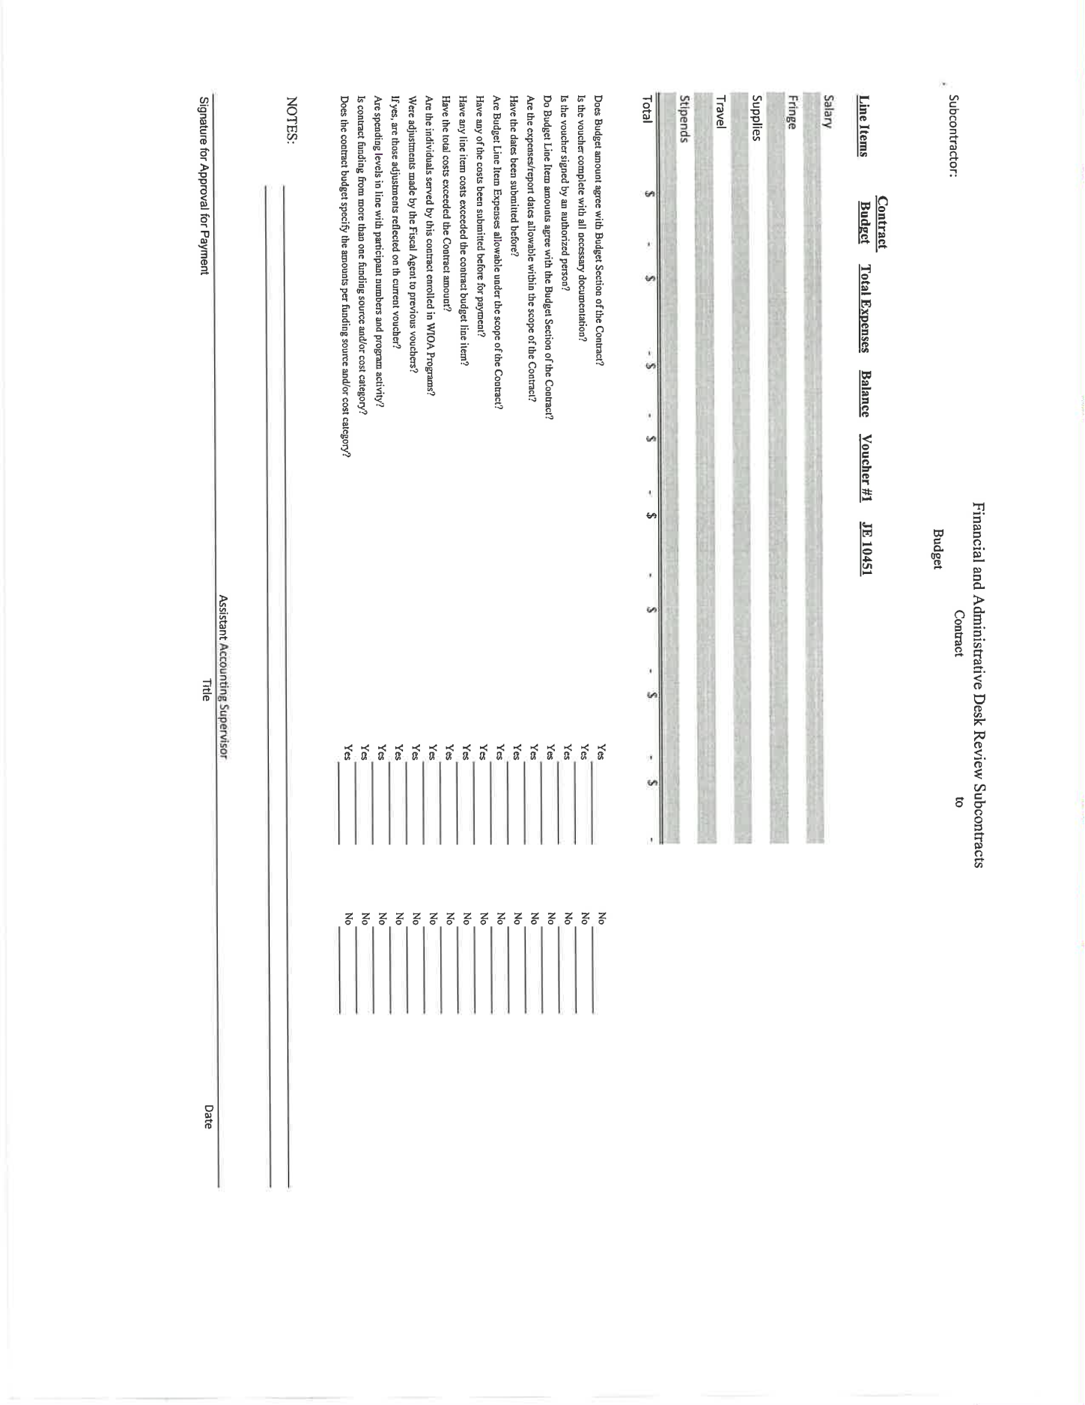
Attachment C
ST. LAWRENCE COUNTY
Financial, Administrative
Review Guide
Workforce Innovation and Opportunity Act

Complaints/Grievances:

On Site EEO Review:

Contractor:

Street Address:

City:

Are EEO posters prominently displayed in a location frequented by WIOA applicants/participants?
Yes No

Are facilities Handicapped accessible: Yes No

What accommodations have been made for the Handicapped:

Are services provided on an equitable basis: Yes No

Attachment D

ST. LAWRENCE COUNTY
Financial and Administrative
Review Guide
Workforce Innovation and Opportunity Act

Notice of Findings to Subrecipient/Contractor:

The contractor will be notified within thirty (30) days of the review, if there are any findings or change in the reimbursement resulting from the review.

Administrative Process for resolution of findings resulting from the Monitor or Financial Desk Review:

The Contractor agrees to attempt to resolve disputes arising from this sub-agreement by administrative processes and negotiation in-lieu-of litigation.

- Any disputes concerning the question of fact arising under this contract which is not settled by informal meetings shall be decided by the Grant Recipient's authorized representative who shall mail the written decision to the Contractor or otherwise furnish a copy.

- In connection with any appeal proceeding under this clause, the Contractor/Subgrantee shall be afforded an opportunity to be heard and to offer evidence in support of its appeal. Pending final decision of a dispute hereunder, the performance of the Contractor shall proceed in accordance with the Grant Recipient's decision.

- This "Dispute" clause does not preclude consideration of law questions in connection with decisions provided above: Provided that nothing in this contract/sub-grant shall be construed as making final the decision of any administrative official, representative or board on a question of law.

Complaints/Grievances:

The following is a part of every Contract
Non-Criminal Complaints and Grievances Procedure:

GRIEVANCE PROCEDURE:

The Contractor agrees to make available and provide information on the grievance procedure relating to the terms and conditions of employment available to the participant.

If the Contractor does not have a grievance procedure in place, he/she agrees to utilize the system established by the Grant Recipient.

Attachment D

DISPUTES:

The Contractor agrees to attempt to resolve disputes arising from this sub-agreement by administrative processes and negotiation in-lieu-of litigation.

- Any disputes concerning the question of fact arising under this contract which is not settled by informal meetings shall be decided by the Grant Recipient's authorized representative who shall mail the written decision to the Contractor or otherwise furnish a copy.

- In connection with any appeal proceeding under this clause, the Contractor/Subgrantee shall be afforded an opportunity to be heard and to offer evidence in support of its appeal. Pending final decision of a dispute hereunder, the performance of the Contractor shall proceed in accordance with the Grant Recipient's decision.

- This "Dispute" clause does not preclude consideration of law questions in connection with decisions provided above: Provided that nothing in this contract/sub-grant shall be construed as making final the decision of any administrative official, representative or board on a question of law.

- The Contractor agrees to pay any debt incurred while in violation of this contract.

Attachment D

St. Lawrence County One-Stop System
Non-Criminal Complaints and Grievances Procedure
Approved by the St. Lawrence County Workforce Investment Board: May 19, 2004
Reaffirmed by the SLC Workforce Development Board: September 9, 2015
Updated by the SLC Workforce Development Board: June 13, 2018
Updated by the SLC Workforce Development Board: June 12, 2024

INTRODUCTION

The Workforce Innovation and Opportunity Act (WIOA) Section 181(c) and the Rules and Regulations 20 CFR 683.60 require the establishment of a complaint/grievance procedure by each Local Area, State and direct recipient of funds under Title I.

As a participant, service provider, or interested party, this document serves to inform you of the procedure whereby you may settle any difference or non-criminal complaint that may arise, free from coercion, restraint, interference, discrimination or reprisal.

PROCEDURE

The Workforce Development Board has implemented the complaint/grievance procedure outlined in Attachment A: WIOA Title I Compliant/Grievance Procedure. The procedure includes the handling of complaints/grievances arising in connection with WIOA Title I programs operated in their Local Workforce Development Area. Attachment A will be provided to customers as notification of the grievance procedure and will include a flowchart depicting the procedure.

The Workforce Development Board has appointed two officers to assume responsibility for investigating the complaint/grievance and seeking resolution.

Local Area Grievance Officer
Heather Owens, Senior Employment & Training Counselor
80 State Highway 310, Suite 8
Canton, NY 13617
howens@stlawco.gov
315-229-3340

Local Level Hearing Officer
Adam Peters, Assistant Accounting Supervisor
80 State Highway 310, Suite 8
Canton, NY 13617
apeters@stlawco.gov
315-229-3307

If these positions are vacated, a replacement must be appointed and Attachment B: Local Area Grievance Officers/Local Level Hearing Officers Form must be submitted to WIOA.Grievance.Procedure@labor.ny.gov.

NOTE TO SERVICE PROVIDERS

NYS Career Center partners, service providers and programs operated by subcontractors in the Local Workforce Development Area must utilize the complaint/grievance system established as outlined in Attachment A. You must inform all participants early of the grievance procedures they are to follow, should they need them.

CUSTOMER COMPLAINT INFORMATION FORM

If there is complaint, the complainant needs to fill out Attachment C: Customer Complaint Information Form. The form is to be completed and returned to the Career Center staff. If it is a discrimination complaint, the form is to be submitted to the Career Center Equal Opportunity Officer or sent to: NYS Department of Labor, Division of Equal Opportunity Development, State Office Campus, Building 12, Room 540, Albany, NY 12240.

Career Center Equal Opportunity Officer
Pam Lewis
St. Lawrence County Workforce Development Board
80 State Highway 310
Canton, NY 13617
plewis@stlawco.gov
315-229-3342

NON CRIMINAL/NON DISCRIMINATION COMPLAINT LOG

The Non Criminal/Non Discrimination Complaint log (Attachment D) needs to be completed when complaints/grievances are received. It contains the elements that are needed for tracking purposes.

EXAMPLE OF NON CRIMINAL/NON DISCRIMINATION COMPLAINT LOG

St. Lawrence County One-Stop System
Non-Criminal Complaints and Grievances Procedure
Program Complaint Resolution Officer:

Complaint Log

Date Received | Complainant Name | Complaint Description | Date Referred Local Complaint Officer | Date Resolution reached/Hearing scheduled | Date of Hearing (if applicable)

LOCAL HEARING AND DECISION – REQUIRED ELEMENTS

Attachment E: Local Hearing and Decision – Required Elements lists the required components of a formal hearing and the decision based on the hearing.

- Hearing Notice Example

St. Lawrence County One-Stop System
Non-Criminal Complaints and Grievances Procedure

Hearing Notice

Date

Complainant Name
Complainant Address
City, State Zip Code

In compliance with Rules and Regulations (Section 667.600) of the Workforce Innovation and Opportunity Act (WIOA) “Subpart F – Grievance Procedures, Complaints, and State Appeals Processes” you are hereby notified that a hearing has been scheduled for the following:

DATE OF HEARING:

TIME OF HEARING:

LOCATION OF HEARING:

The purpose of this hearing is to provide you and/or your attorney, and/or your designated representative with the opportunity to address your grievance/complaint with the St. Lawrence County One-Stop System, as outlined in the “Non-Criminal Complaints and Grievances Procedure”. If you have any questions regarding the hearing, I have attached for your information the hearing guidelines that will be followed.

(Short and plain statement of the matters asserted)

Sincerely,

John Doe
Complaint Resolution Officer

XC: Party(ies) involved
WDB Chairperson
Hearing Committee members

- Hearing Guidelines

- The hearing shall be recorded.

- The complainant may be represented by an attorney or other designated representatives.

- To the extent possible, consistent with a fair determination of the issues, the identity of any person who has furnished information related to an investigation to a WIOA Title I related problem, shall be kept confidential.

- Within the limitations of the Freedom of Information Act, the complainant has a right of access to relevant records and documents that the program and/or Local Area maintains.

- The complainant and respondent have the right to an opportunity to present evidence relevant to the complaint, to call witnesses, and cross-examine other parties and their witnesses.

- Hearing Decision

A formal decision must contain the following:
- Name of Complainant
- Name of Respondent
- State the specific legal authority for holding the hearing
- Date of hearing
- List of Attendees
- Statement of issues
- Finding of facts
- Conclusions of law
- Opinion and reason for decision
- Signature of hearing officer
- Date signed

